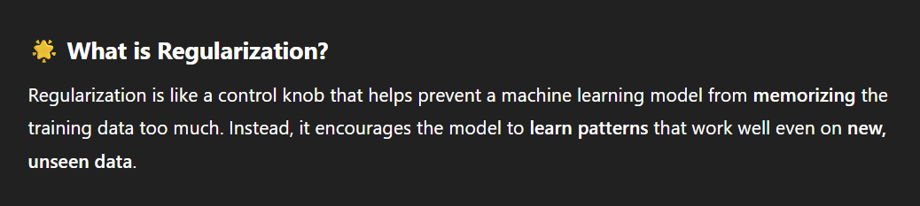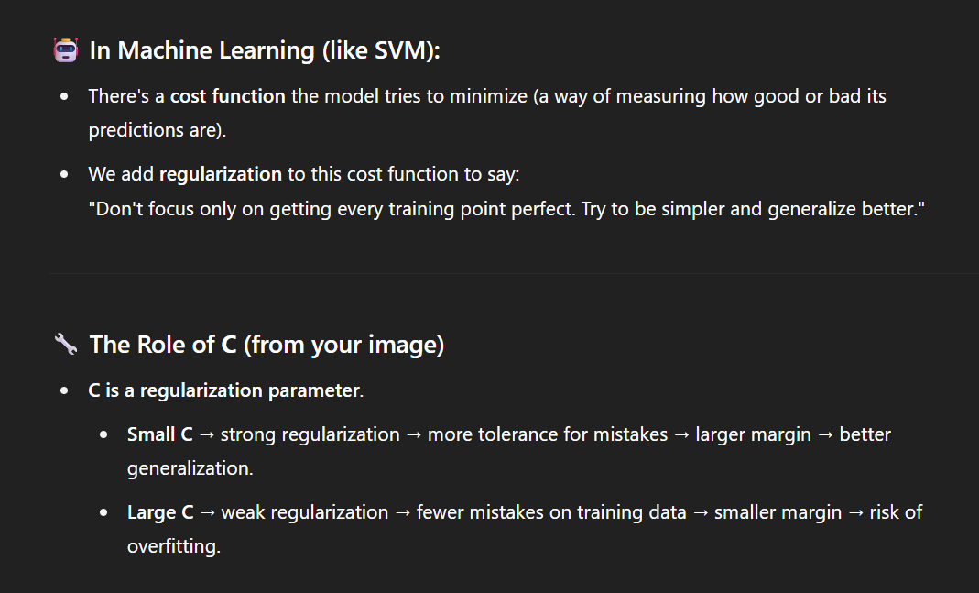

https://programmathically.com/understanding-hinge-loss-and-the-svm-cost-function/

